**IP5108 I2C description:**

7-bit slave address IP5108 is 0x75 (byte with write bit = 0xEA; byte with read bit = 0xEB)  
400 Kbps speed of I2C supported  
1 byte data = 8-bit data (bits from 7 to 0)

**WRITE Arduino example:**  
Wire.beginTransmission(0x75);  
Wire.write(register_address_byte);  
Wire.write(data_byte);  
Wire.endTransmission();

**READ Arduino example:**  
Wire.beginTransmission(0x75);  
Wire.write(register_address_byte);  
Wire.endTransmission();  
Wire.requestFrom(0x75,1);  
data_byte = Wire.read();

**REGISTERS:**

**1. Enable / disable functions:**  
SYS_CTL0 = 0x01:

* bit 4 (read/write): 0 = disbale / 1 = enable (1 = after reset) detection ??? (I do not understand.)
* bit 3 (read/write): 0 = disbale / 1 = enable (1 = after reset) light
* bit 2 (read/write): 0 = disbale / 1 = enable (1 = after reset) booster
* bit 1 (read/write): 0 = disable / 1 = enable (1 = after reset) charger

SYS_CTL1 = 0x02:

* bit 1 (read/write): 0 = disable / 1 = enable (1 = after reset) auto-standby
* bit 0 (read/write): 0 = disable / 1 = enable (1 = after reset) auto ??? (I do not understand.)

SYS_CTL3 = 0x03:

* bit 5 (read/write): 0 = disable / 1 = enable (1 = after reset) off by button

**2. General setup features:**  
SYS_CTL2 = 0x0C:

* bits 7-3 (read/write): (01010 = after reset) auto-standby current limit as multiple 12 mA

SYS_CTL4 = 0x04:

* bits 7-6 (read/write): (10 = after reset) time for auto-standby: 00=8s, 01=16s, 10=32s, 11=64s

SYS_CTL3 = 0x03:

* bits 7-6 (read/write): (01 = after reset) time for recognition button press: 00=1s, 01=2s, 10=3s, 11=4s

SYS_CTL5 = 0x07:

* bit 1 (read/write): (0 = after reset) control of light by button: 0=press, 1=double click
* bit 0 (read/write): (0 = after reset) off by button: 0=double click, 1=press

**3. Charging setup features:**  
CHARGER_CTL1 = 0x22:

* bits 3-2 (read/write): (01 = after reset) VOUT undervoltage limit during chargig: 00=4.53V, 01=4.63V, 10=4.73V, 11=4.83V

CHARGER_CTL2 = 0x24:

* bits 6-5 (read/write): (00 = after reset) battery type = charging voltage: 00=4.2V, 01=4.3V, 10=4.35V
* bits 2-1 (read/write): (10 = after reset) overcharging of charging: 00=0mV, 01=14mV, 10=28mV, 11=42mV

CHG_DIG_CTL4 = 0x25:

* bits 4-0 (read/write): (10110 = after reset) charging current setting [A]:  
  b0 x 0.1 + b1 x 0.2 + b2 x 0.4 + b3 x 0.6 + b4 x 1.4

**4. Charging information:**  
Reg_READ0a = 0x70:

* bit 3 (read only): charging status: 0 = not charging, 1 = charging

Ref_READ0b = 0x71:

* bits 7-5 (read only): detailed charging status:  
  000 = inactivity  
  001 = charging  
  010 = constant current charging  
  011 = charging with constant voltage  
  100 = ??? (missing description in original document)  
  101 = end of charging (maintenance current)
* bit 3 (read only): signal of end of charging (=1)

**5. PIN assignment & control:**  
MFP_CTL0 = 0x51:

* bits 5-4 (read/write): (00 = after reset) pin LIGHT assignement: 00=WLED, 01=GPIO2, 10=VREF
* bits 3-2 (read/write): (00 = after reset) pin L4 assignement: 00=L4, 01=GPIO1
* bits 1-0 (read/write): (00 = after reset) pin L3 assignement: 00=L3, 01=GPIO0

GPIO_CTL2a = 0x53:

* bits 2-0 (read/write): (000 = after reset) GPIO[2:0] input enable

GPIO_CTL2b = 0x54:

* bits 2-0 (read/write): (000 = after reset) GPIO[2:0] output enable

GPIO_CTL3 = 0x55:

* bits 2-0 (read/write): (000 = after reset) GPIO[2:0] data

**6. Measurement:**  
BATVADC_DAT0 = 0xA2:

* pins 7-0 (read only): LOW 8 bits (byte) of BATVADC

BATVADC_DAT1 = 0xA3:

* pins 5-0 (read only): HIGH 6 bits of BATVADC

Calculation according to the original document:  
[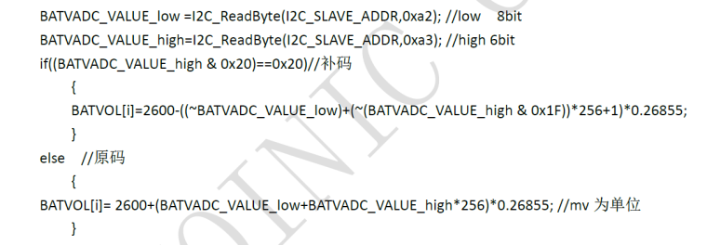](https://forum.m5stack.com/assets/uploads/files/1535826836669-batvadc.png)

BATIADC_DAT0 = 0xA4:

* pins 7-0 (read only): LOW 8 bits (byte) of BATIADC

BATIADC_DAT1 = 0xA5:

* pins 5-0 (read only): HIGH 6 bits of BATIADC

Calculation according to the original document:  
[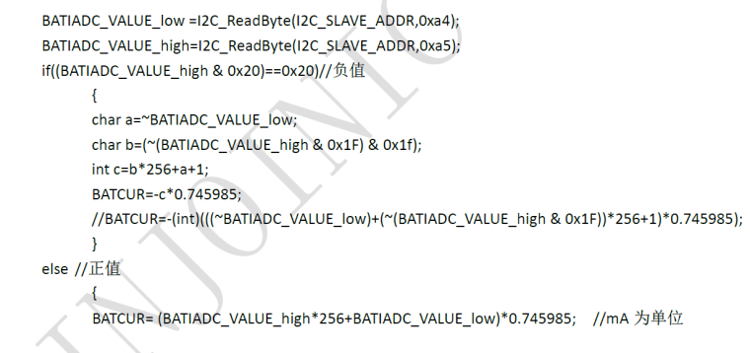](https://forum.m5stack.com/assets/uploads/files/1535825485669-batiadc.png)

BATOCV_DAT0 = 0xA8:

* pins 7-0 (read only): LOW 8 bits (byte) of BATOCV

BATOCV_DAT1 = 0xA9:

* pins 5-0 (read only): HIGH 6 bits of BATOCV

Calculation according to the original document:  
[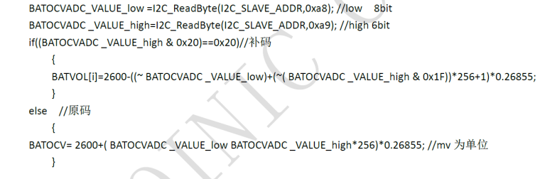](https://forum.m5stack.com/assets/uploads/files/1535825505024-batocvadc.png)

This is true: BATOCV = BATVACD + BATIADC * battery_internal_resistnace

**7. WLED status:**  
Reg_READ1 = 0x72:

* bit 7 (read only): 0 = WLED is off, 1 = WLED is on

**8. Light / heavy load:**  
Reg_READ1 = 0x72:

* bit 6 (read only): 0 = heavy load over 75 mA, 1 = light load less 75 mA

**9. Button control:**  
Reg_READ2 = 0x77:

* bit 3 (read; write 1 = reset) flag button double clicked (=1)
* bit 1 (read; write 1 = reset) flag button pressed (=1)
* bit 0 (read; write 1 = reset) flag button clicked (=1)

That is all.